EXPERIMENT-2

Simulation and Performance
Evaluation of People–Process–Data–Things IoE Framework using Edge/Fog-to-Cloud Pipeline

Objective:
To simulate and evaluate a People–Process–Data–Things (PPDT) Internet of Everything (IoE) framework using an Edge/Fog-to-Cloud pipeline to improve data processing efficiency, reduce
latency, optimize bandwidth usage, and enhance system performance, reliability, and scalability.

Procedure:
- Design the PPDT-based IoE framework.
- Simulate IoE devices generating real-time data.
- Process data at the Edge and Fog layers.
- Transfer processed data to the Cloud for storage and analysis.
- Evaluate latency, throughput, bandwidth, and energy efficiency.
- Compare the results with a cloud-only approach.
- Analyze the results to assess overall system performance.

Number of sources: 2

 | Edge | Fog | Cloud
Propagation Delay | 2.5 | 11 | 42
Processing Delay | 4.5 | 8.5 | 17
Queueing Delay | 1.2 | 3.5 | 6.5
End-to-End Delay | 8.259 ms | 23.15 ms | 65.5 ms

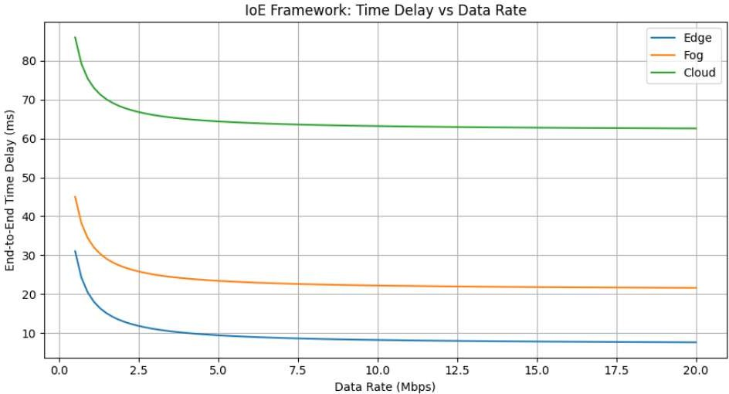
Number of source:15

 | Edge | Fog | Cloud
Propagation Delay | 18 | 80 | 310
Processing Delay | 32 | 65 | 125
Queueing Delay | 8.5 | 24 | 48
End-to-End Delay | 58.659 ms | 169.659 ms | 488.159 ms
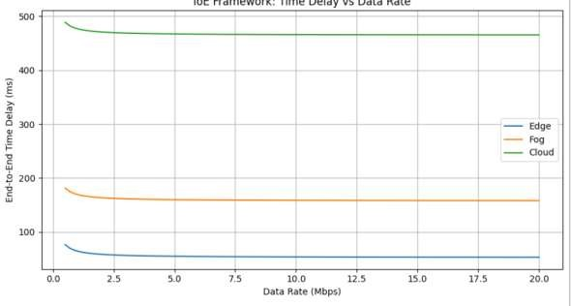

Result:
Edge computing provides the lowest end-to-end delay compared to Fog and Cloud for both 2 and 15 sources. As the number of sources increases, delay also increases. Therefore, Edge is best for real-time IoE applications, Fog provides moderate performance, and Cloud is suitable for large-scale data processing.

